TITANIC PASSENGER SURVIVAL ANALYSIS:
An End-to-End Data Science Project
Comprehensive Final Report — Week 5
Data Science / Machine Learning Internship Program
Prepared by: Sanket Udaykumar Sutar
Submission Date: 15 August 2026
Dataset: Titanic Passenger Dataset (Titanic_Cleaned.csv, 891 records)
Tools: Python, Pandas, NumPy, SciPy, Scikit-learn, Matplotlib, Seaborn

Declaration
I hereby declare that this report, “Titanic Passenger Survival Analysis: An End-to-End Data Science Project,” is a consolidation of independent work carried out by me across Weeks 1–5 of the Data Science / Machine Learning internship. All data cleaning, exploratory analysis, statistical testing, and machine learning work referenced in this report builds on the weekly submissions I completed during the internship. Sources of external reference material are acknowledged in the References section.

Signature: Sanket Udaykumar Sutar
Date: 15 August 2026

Acknowledgement
I would like to express my sincere gratitude to the mentors and coordinators of the Data Science / Machine Learning Internship Program for their guidance and structured weekly tasks, which enabled a progressive, end-to-end understanding of the data science workflow — from raw data to actionable business insight. I am also thankful for the opportunity to work with the Titanic dataset, a well-established resource for learning data cleaning, visualization, statistical inference, and machine learning.

Executive Summary
This report consolidates a five-week, end-to-end data science project built on the Titanic passenger dataset (891 records). The project moved sequentially through data preparation and exploratory analysis (Week 1), data storytelling through visualization (Week 2), inferential statistics and hypothesis testing (Week 3), supervised machine learning (Week 4), and, in this final week, an integrated synthesis with strategic recommendations.
The dataset was cleaned by imputing missing Age values with the median, imputing missing Embarked values with the mode, and removing the sparsely populated Cabin column, producing the analysis-ready file Titanic_Cleaned.csv. Exploratory analysis showed that 61.6% of the 891 passengers did not survive, that the majority travelled in third class, and that most passengers were between 20 and 40 years old.
Statistical testing confirmed that gender was strongly and significantly associated with survival (χ² = 260.72, p < 0.001, Cramér's V = 0.54 — a large effect), that ticket fare differed significantly across passenger classes (ANOVA F = 452.46, p < 0.001), and that, in contrast, average passenger age did not differ significantly between survivors and non-survivors (t = −0.12, p = 0.90).
Two supervised classification models were trained to predict survival from passenger characteristics. Logistic Regression achieved 80.4% accuracy and an ROC-AUC of 0.843, outperforming a Decision Tree classifier (78.8% accuracy) on overall accuracy, recall, and F1-score, while the Decision Tree achieved marginally higher precision. Both models showed a consistent weakness in recall for the survivor class, correctly identifying only 55–67% of actual survivors.
Bringing the visual, statistical, and predictive evidence together, this report concludes that gender and passenger class were the dominant factors associated with survival outcome, while age played a comparatively minor role. Four strategic recommendations are proposed, reframing these historical findings as lessons for modern emergency planning: prioritizing vulnerable groups during evacuation, ensuring equitable access to safety resources regardless of economic status, using predictive analytics to support real-time emergency planning, and regularly testing safety procedures using measurable data. The report closes with a discussion of the project's limitations — chiefly its historical, single-event, observational nature — and concrete directions for future improvement, including feature engineering, cross-validation, hyperparameter tuning, and ensemble methods such as Random Forest and Gradient Boosting.

Table of Contents
Note: this is a static contents list. If opened in Microsoft Word, right-click and choose “Update Field” on any auto-generated field elsewhere in the document to refresh page references.

- Declaration
- Acknowledgement
- Executive Summary
- List of Figures
- 1. Introduction
- 2. Problem Statement
- 3. Project Objectives
- 4. Dataset Description
- 5. Project Methodology
- 6. Data Acquisition and Preparation (Week 1)
- 7. Exploratory Data Analysis (Week 1)
- 8. Data Visualization and Storytelling (Week 2)
- 9. Statistical Analysis and Hypothesis Testing (Week 3)
- 10. Machine Learning Model Development (Week 4)
- 11. Model Evaluation
- 12. Integrated Findings
- 13. Strategic Recommendations
- 14. Business / Research Implications
- 15. Limitations
- 16. Future Improvements
- 17. Conclusion
- 18. References
- Appendix A — Python Code

List of Figures
- Figure 1. Passenger Class Distribution
- Figure 2. Survival Rate by Gender
- Figure 3. Survival Rate by Passenger Class
- Figure 4. Age Distribution by Survival Status
- Figure 5. Ticket Fare by Passenger Class
- Figure 6. Age Distribution by Survival (Hypothesis Testing Preview)
- Figure 7. Survival by Gender (Hypothesis Testing Preview)
- Figure 8. Fare Distribution Across Passenger Classes (Hypothesis Testing Preview)
- Figure 9. Confusion Matrix — Logistic Regression
- Figure 10. ROC Curve — Logistic Regression (AUC = 0.84)
- Figure 11. Model Comparison — Logistic Regression vs. Decision Tree

1. Introduction
Data science creates value by moving systematically from raw, unstructured information to validated insight and, ultimately, to decisions. This project uses that full workflow — data preparation, exploratory visualization, statistical hypothesis testing, and machine learning — on a single, well-understood dataset: passenger records from the RMS Titanic.
Rather than treating each of the previous four internship weeks as an isolated exercise, this final report integrates them into one coherent narrative. Data cleaning made the dataset trustworthy; exploratory analysis and storytelling revealed visible patterns; hypothesis testing established which of those patterns were statistically significant rather than coincidental; and machine learning tested whether the same characteristics could predict individual outcomes. Each stage builds on the one before it, and each adds a different kind of evidence — descriptive, inferential, and predictive — to the same underlying question.
The Titanic dataset is well suited to this purpose because it is small enough to analyze thoroughly, yet rich enough to contain genuine demographic, socioeconomic, and outcome variables: passenger class, sex, age, fare, family composition, and survival status. Because the disaster and its evacuation record are historically documented, the patterns found in the data can also be sanity-checked against real-world context (for example, the “women and children first” evacuation convention), which makes it a strong teaching case for connecting statistical evidence to real-world interpretation.

2. Problem Statement
The objective of this project is to analyze the factors associated with passenger survival on the Titanic and to use statistical and machine learning techniques to understand these patterns and develop a predictive model of survival outcome.
Framed as a research question:
Key takeaway: What passenger characteristics were associated with survival on the Titanic, and how can statistical analysis and machine learning be used to understand and predict survival outcomes?

3. Project Objectives
- Clean and preprocess the Titanic dataset, resolving missing values and inconsistent fields.
- Perform exploratory data analysis (EDA) to understand the structure and distribution of the data.
- Develop meaningful visualizations that communicate passenger composition and survival patterns to a non-technical audience.
- Identify important relationships between passenger characteristics (gender, class, age, fare) and survival.
- Perform statistical hypothesis testing to determine which observed patterns are statistically significant.
- Develop supervised machine learning classification models to predict survival.
- Evaluate model performance using accuracy, precision, recall, F1-score, and ROC-AUC.
- Identify the limitations of the dataset, the statistical tests, and the models.
- Develop data-driven strategic recommendations relevant to safety and risk management.

4. Dataset Description
The analysis uses the classic Titanic passenger dataset, comprising 891 passenger records and 11 original columns before feature selection. Following the Week 1 cleaning process, the dataset was saved as Titanic_Cleaned.csv and used as the single analytical source for all subsequent weeks.
Feature | Description
PassengerId | Unique passenger identifier
Survived | Survival status (0 = No, 1 = Yes) — target variable
Pclass | Passenger / ticket class (1st, 2nd, 3rd)
Name | Passenger name
Sex | Passenger gender
Age | Passenger age in years
SibSp | Number of siblings / spouses aboard
Parch | Number of parents / children aboard
Ticket | Ticket number
Fare | Ticket fare paid
Cabin | Cabin information (removed during cleaning — largely missing)
Embarked | Port of embarkation (C, Q, S)

PassengerId, Name, Ticket, and Cabin were excluded from statistical testing and modeling because they are identifiers or free-text fields with no direct predictive or explanatory value for a baseline analysis. The overall target class distribution is moderately imbalanced: 549 passengers (61.6%) did not survive and 342 passengers (38.4%) survived.

5. Project Methodology
The project followed a linear, reproducible pipeline that mirrors the standard data science lifecycle, with each stage corresponding to one week of the internship:
- Data Acquisition — obtaining the raw Titanic passenger dataset.
- Data Understanding — inspecting structure, data types, and missing values.
- Data Cleaning — imputing missing values and removing unusable columns.
- Exploratory Data Analysis — summarizing distributions and relationships.
- Data Visualization & Storytelling — building a narrative sequence of charts for a non-technical audience.
- Statistical Hypothesis Testing — formally testing whether observed patterns are significant.
- Feature Engineering & Encoding — preparing variables for machine learning.
- Machine Learning — training classification models to predict survival.
- Model Evaluation — assessing predictive performance with multiple metrics.
- Integrated Insights — combining visual, statistical, and predictive evidence.
- Strategic Recommendations — translating findings into actionable guidance.

Throughout, the project used pandas and NumPy for data handling, Matplotlib and Seaborn for visualization, SciPy for statistical testing, and Scikit-learn for machine learning.

6. Data Acquisition and Preparation (Week 1)
The Week 1 task focused on inspecting and cleaning the raw Titanic dataset so that it could be reliably used in every subsequent stage of the project.

6.1 Data Inspection
The dataset was loaded with pandas and inspected using df.head(), df.shape, df.info(), and df.describe() to understand its structure, column data types, and summary statistics. A missing-value audit (df.isna().sum()) identified substantial gaps in Age, Embarked, and especially Cabin.

6.2 Cleaning Decisions
Field | Issue | Action Taken | Rationale
Age | ≈ 20% missing | Imputed with median age | Median is robust to the right-skew typical of age data
Embarked | 2 missing values | Imputed with mode (most frequent port) | Categorical variable with very few missing values
Cabin | ≈ 77% missing | Column dropped | Too sparse to impute reliably or use as a feature
Duplicates | Checked | None material found / removed if present | Ensures each row represents one unique passenger

The cleaned dataset was saved as Titanic_Cleaned.csv and used as the single source of truth for Weeks 2 through 5.

7. Exploratory Data Analysis (Week 1)
Week 1 produced five foundational exploratory visualizations — survival count, passenger class distribution, age distribution, survival by gender, and fare distribution — plus a correlation heatmap of numeric variables. The equivalent, more polished versions of the class-distribution, gender, and fare charts are presented in Section 8 as part of the Week 2 data-storytelling narrative, so they are summarized here rather than duplicated.
Finding | Observation | Insight
Survival count | More passengers died than survived | The target class is moderately imbalanced (61.6% vs 38.4%)
Passenger class | Most passengers traveled in 3rd class | The dataset over-represents lower-ticket-class passengers
Age distribution | Most passengers were 20–40 years old | The dataset mainly reflects a young/middle-aged adult population
Survival by gender | Female passengers had a much higher survival rate | Gender appears to be an important early candidate predictor
Fare distribution | Most fares were low; a few were very high outliers | Fare is right-skewed and should be interpreted alongside class

A correlation heatmap of the numeric variables (Survived, Pclass, Age, SibSp, Parch, Fare) was also produced to screen for linear relationships worth following up on in later weeks; this early, purely descriptive signal was one of the motivations for the formal hypothesis tests carried out in Week 3 (Section 9).

8. Data Visualization and Storytelling (Week 2)
Week 2 reframed the exploratory charts as a narrative sequence for a non-technical audience: first describing who was on board, then examining who survived, and finally considering which passenger characteristics were associated with different outcomes. Causal language was deliberately avoided in favor of “associated with,” “linked to,” and “suggests,” since the dataset is observational.

8.1 Who Were the Passengers?
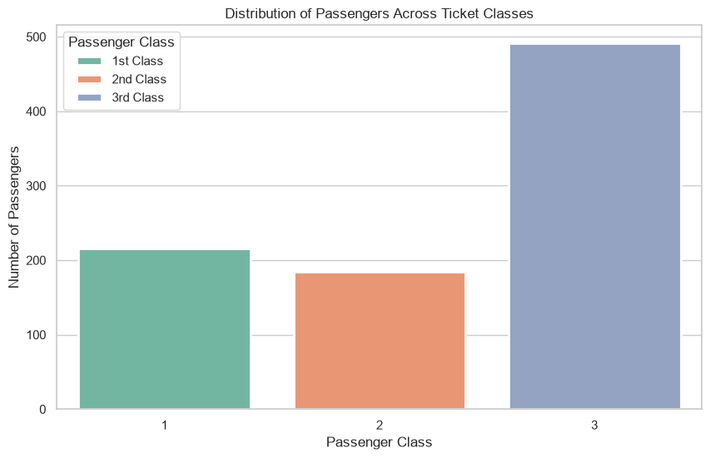
Figure 1. Passenger Class Distribution
Third class was the largest group aboard, establishing that the passenger population spanned different economic backgrounds and making class a meaningful comparison variable for later charts.

8.2 Did Gender Matter?
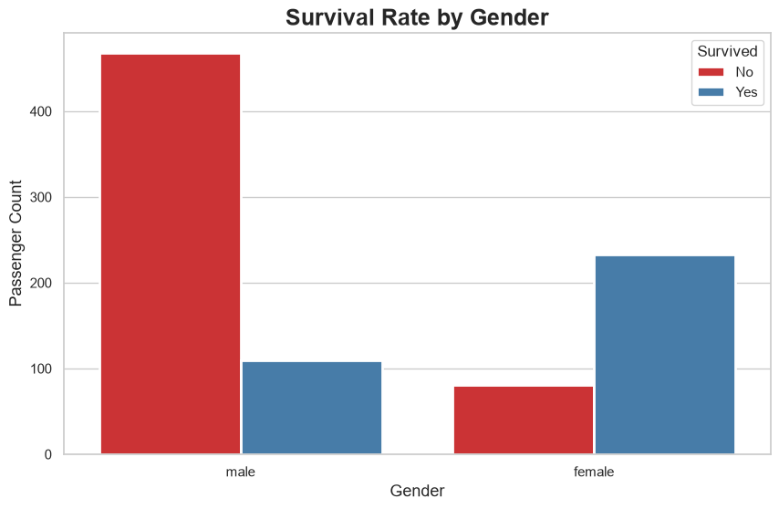
Figure 2. Survival Rate by Gender
Women represented a much larger share of survivors relative to their group size than men did. This pattern is consistent with the historically documented “women and children first” evacuation convention, though the chart alone shows association rather than the complete mechanism.

8.3 Did Economic Status (Class) Matter?
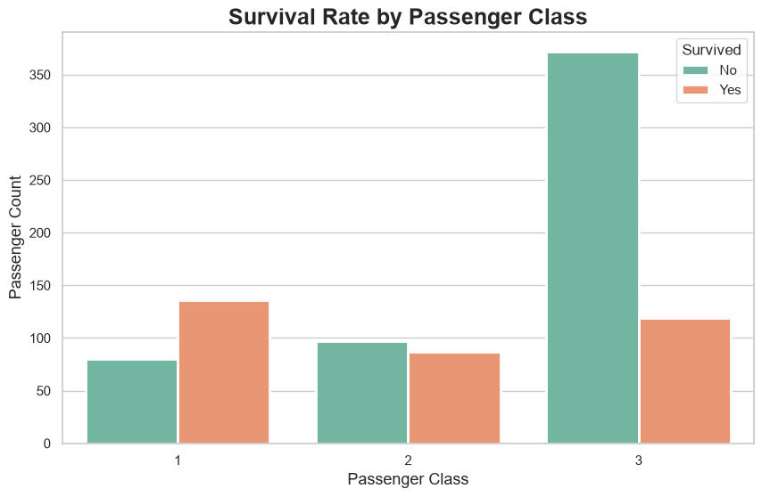
Figure 3. Survival Rate by Passenger Class
First-class passengers show a visibly more favorable survival outcome, third-class passengers a less favorable one, with second class positioned between them. This suggests that social and economic position may have shaped access to information, routes, lifeboats, and evacuation time — while acknowledging that some lower-class passengers survived and some first-class passengers did not.

8.4 Did Age Matter?
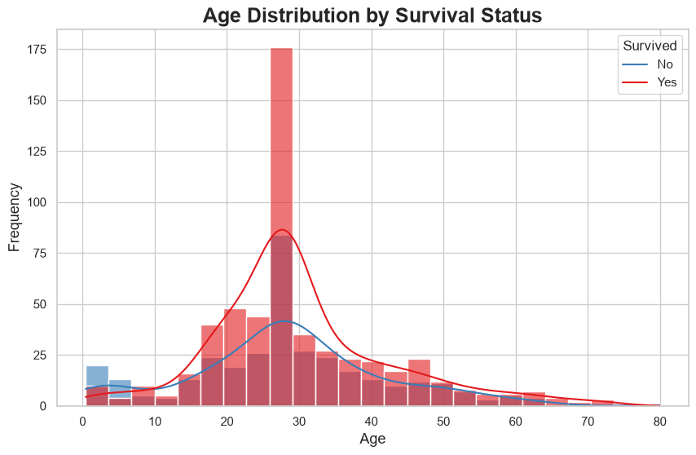
Figure 4. Age Distribution by Survival Status
The age distributions of survivors and non-survivors overlap substantially, suggesting that age differentiates the two outcome groups less clearly than gender or class do in this dataset — a visual impression later confirmed statistically in Section 9.

8.5 How Did Fares Differ?
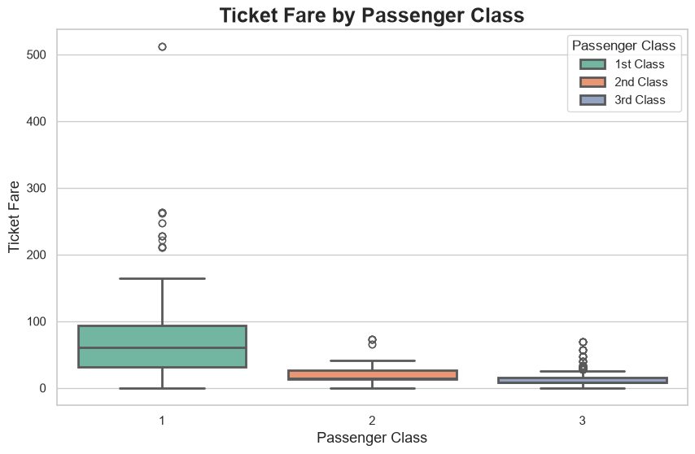
Figure 5. Ticket Fare by Passenger Class
Higher fares are generally associated with higher ticket classes, reinforcing the interpretation that passengers did not experience the voyage under identical economic conditions. Fare is not, however, a direct measure of personal wealth or physical access to a lifeboat, since shared tickets and cabin arrangements can affect its meaning.
Key takeaway: Survival was unevenly distributed across the passenger population. Gender and passenger class provide the clearest visual contrasts, age adds demographic context without a strong separation on its own, and fare helps explain the socioeconomic structure behind class.

9. Statistical Analysis and Hypothesis Testing (Week 3)
Week 3 moved beyond descriptive charts to formally test whether three patterns observed during exploration were statistically significant, using a 5% significance level (α = 0.05). A p-value below α is treated as evidence against the null hypothesis; results above α are reported as “fail to reject H₀” rather than “accept H₀.”

9.1 Test 1 — Independent-Samples t-test: Age vs. Survival
Research question: Did survivors have a different average age than non-survivors? An independent two-sample Welch's t-test (which does not assume equal group variances) was applied, comparing the ages of the 342 survivors and 549 non-survivors after excluding missing Age values.
H₀ (Null) | H₁ (Alternative) | t-statistic | df | p-value | Decision
Mean age is equal for survivors and non-survivors. | Mean age differs between the groups. | −0.120 | 889 | 0.905 | Fail to reject H₀

Interpretation: with p = 0.905, far above α = 0.05, there is no statistically significant difference in average age between survivors and non-survivors in this dataset. This confirms the visual impression from Section 8.4 — age alone is a weak discriminator of survival outcome.

9.2 Test 2 — Chi-square Test of Independence: Gender vs. Survival
Research question: Is gender associated with survival? A chi-square test of independence compared the observed Sex × Survived contingency table against the counts expected under independence.
H₀ (Null) | H₁ (Alternative) | χ² statistic | df | p-value | Decision
Gender and survival are independent. | Gender and survival are associated. | 260.717 | 1 | < 0.001 | Reject H₀

Interpretation: the extremely small p-value provides strong evidence that gender and survival are associated in this dataset. The effect size, Cramér's V ≈ 0.54, is large by conventional benchmarks, indicating that this is not merely a statistically significant but practically negligible relationship — gender is one of the strongest single predictors of survival available in the data. This finding directly reinforces the visual pattern in Section 8.2.

9.3 Test 3 — One-Way ANOVA: Fare vs. Passenger Class
Research question: Did passengers in different ticket classes pay significantly different fares? A one-way ANOVA tested whether the mean fare was equal across all three passenger classes.
H₀ (Null) | H₁ (Alternative) | F-statistic | df | p-value | Decision
Mean fare is equal across all classes. | At least one class has a different mean fare. | 452.456 | (2, 888) | < 0.001 | Reject H₀

Interpretation: the result is highly statistically significant, confirming that ticket fare differs substantially across passenger classes, consistent with Section 8.5. A Tukey HSD post-hoc test would be the natural next step to confirm that all three pairwise class comparisons (not only the overall omnibus test) are individually significant.

9.4 Summary of Hypothesis Test Results
Research Question | Test | Statistic | p-value | Decision
Age vs. survival | Welch's t-test | t = −0.120 | 0.905 | Fail to reject H₀
Gender vs. survival | Chi-square | χ² = 260.72 | < 0.001 | Reject H₀
Fare vs. class | One-way ANOVA | F = 452.46 | < 0.001 | Reject H₀

9.5 Supporting Visualizations
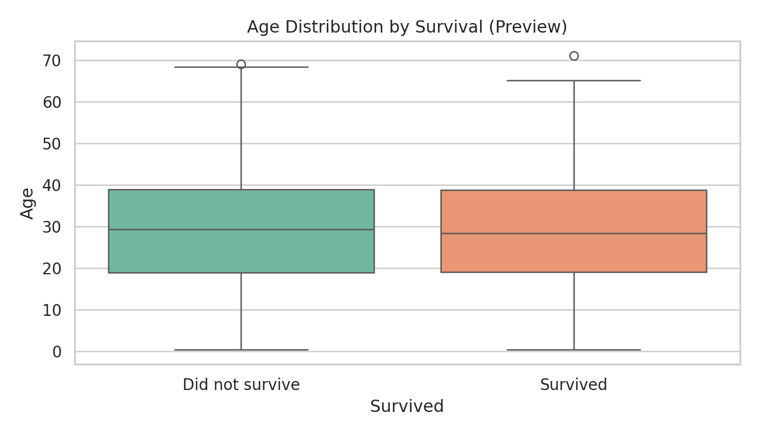
Figure 6. Age Distribution by Survival
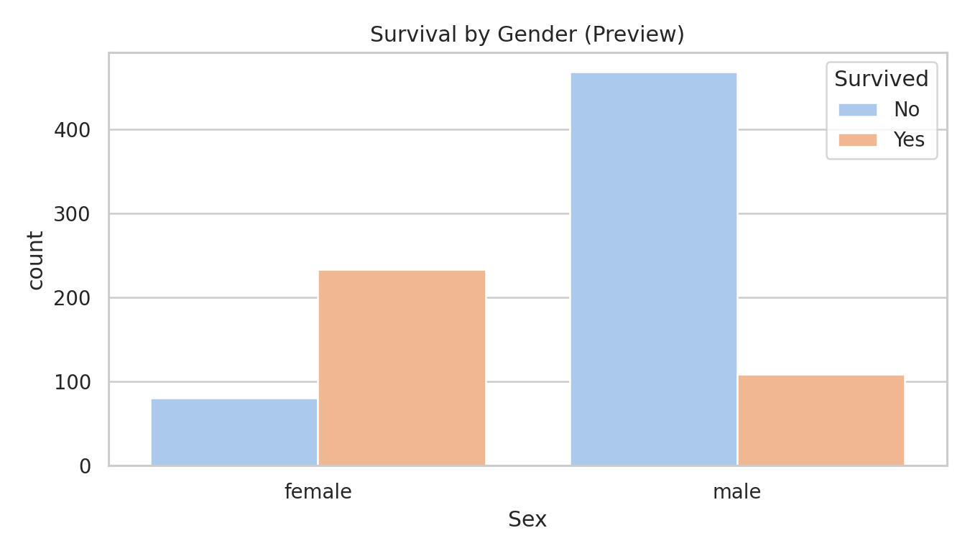
Figure 7. Survival by Gender
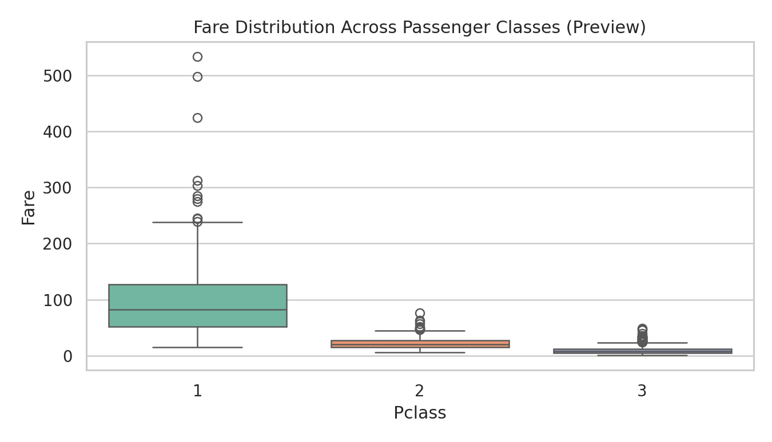
Figure 8. Fare Distribution Across Passenger Classes
Note on scope and rigor: the dataset is observational, so these tests establish statistical association and mean differences, not causation. Multiple hypothesis tests slightly increase the chance of at least one false positive; a stricter correction (e.g., Holm) could be applied for a fully rigorous analysis. ANOVA assumptions of independence, approximate normality, and comparable variances should also be checked, particularly because fare is right-skewed.

10. Machine Learning Model Development (Week 4)
Week 4 tested whether the associations identified statistically in Week 3 could be used to predict individual survival outcomes. Titanic survival was framed as a binary classification problem (Survived: 0 = No, 1 = Yes), using seven predictive features: Pclass, Sex, Age, SibSp, Parch, Fare, and Embarked. Identifier and free-text fields (PassengerId, Name, Ticket, Cabin) were excluded.

10.1 Data Preparation for Modeling
- Feature selection: the seven features above were selected as inputs (X), with Survived as the target (y).
- Categorical encoding: Sex and Embarked were one-hot encoded (drop_first=True) to avoid the dummy-variable trap, producing Sex_male, Embarked_Q, and Embarked_S.
- Train/test split: an 80/20 stratified split preserved the survival class ratio, yielding 712 training rows and 179 test rows.
- Feature scaling: StandardScaler was fit on the training data only and applied to both partitions, standardizing features for Logistic Regression; the Decision Tree, being threshold-based, used unscaled data.

10.2 Models Trained
Two classifiers were trained and compared:
- Logistic Regression (primary model) — simple, fast, and highly interpretable; models the probability of survival directly via the logistic function.
- Decision Tree (comparison model, max_depth = 4) — captures non-linear relationships and feature interactions; depth was restricted to reduce overfitting risk on a relatively small dataset.

11. Model Evaluation

11.1 Performance Metrics
Model | Accuracy | Precision | Recall | F1-Score | ROC-AUC
Logistic Regression | 80.45% | 79.31% | 66.67% | 72.44% | 0.843
Decision Tree | 78.77% | 84.44% | 55.07% | 66.67% | —

Logistic Regression achieved the higher overall accuracy, recall, and F1-score, while the Decision Tree achieved higher precision — it is more conservative, correct 84.4% of the time when it predicts survival, but misses a larger share of actual survivors (55.1% recall) than Logistic Regression (66.7% recall). Given that accuracy, recall, and F1 all favor Logistic Regression, and combined with its strong ROC-AUC of 0.843 (“good” discrimination), it is judged the stronger overall baseline model for this dataset.

11.2 Confusion Matrix
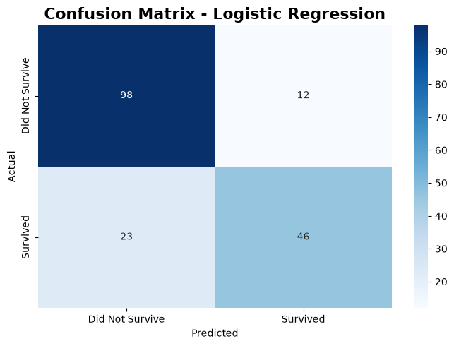
Figure 9. Confusion Matrix — Logistic Regression
The matrix confirms that the model is more accurate at identifying non-survivors than survivors: false negatives (missed survivors) are more common than false positives, meaning roughly a third of passengers who actually survived were misclassified as non-survivors.

11.3 ROC Curve
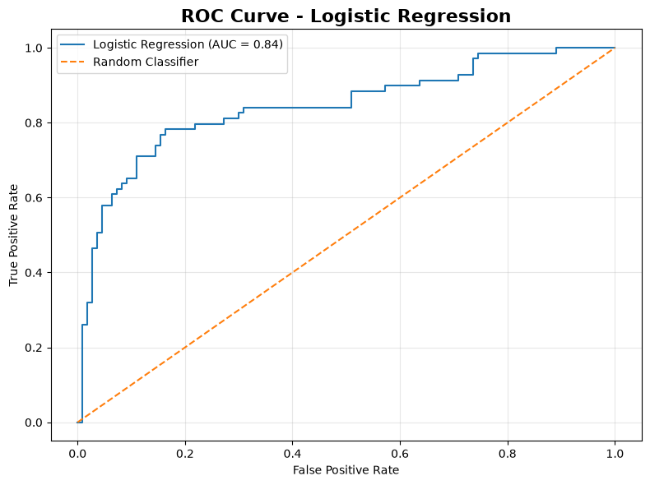
Figure 10. ROC Curve — Logistic Regression (AUC = 0.84)
With an AUC of 0.843, the Logistic Regression model falls in the “good” discrimination range (0.80–0.90), indicating it separates survivors from non-survivors substantially better than chance, even though recall on the positive class is more modest at the default 0.5 threshold. Adjusting the classification threshold could trade some precision for improved recall if identifying survivors is the operational priority.

11.4 Model Comparison
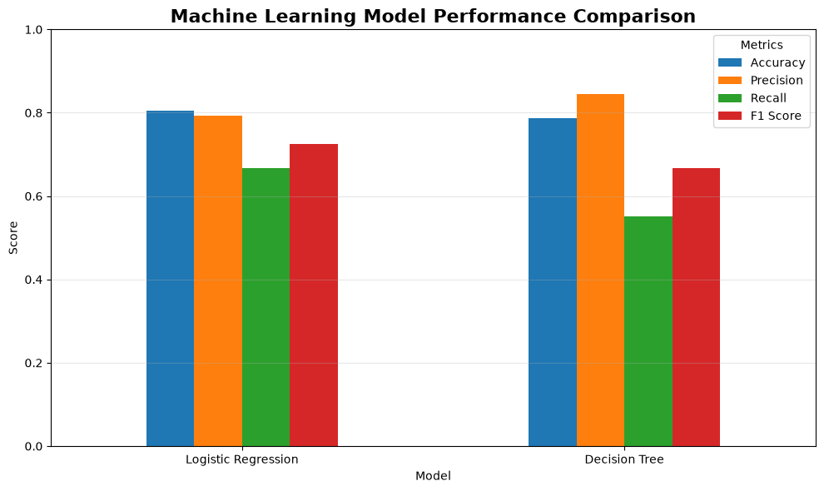
Figure 11. Model Comparison — Logistic Regression vs. Decision Tree

11.5 Overfitting, Underfitting, and Error Analysis
Overfitting risk in the Decision Tree was mitigated by restricting max_depth to 4, forcing the tree to generalize using broad patterns rather than memorizing individual training examples; an unconstrained tree could reach near-100% training accuracy while performing considerably worse on unseen data. Logistic Regression's linear decision boundary carries some risk of underfitting if the true relationship is highly non-linear, but its moderate-to-good performance (80.4% accuracy, 0.843 AUC) suggests it captures a meaningful portion of the underlying signal.
Several factors likely contribute to the recall shortfall on the survivor class in both models:
- Missing information: precise cabin location and exact evacuation circumstances were unavailable, even after cleaning.
- Feature limitations: proximity to lifeboats, swimming ability, and specific crew decisions are not captured by the available columns.
- Historical, single-event dataset: patterns reflect the unique social and procedural context of 1912, including “women and children first” norms.
- Class imbalance: 61.6% non-survivors vs. 38.4% survivors gives the model more examples of the majority class to learn from.
- Model simplicity and sample size: Logistic Regression assumes an approximately linear relationship in log-odds, and both models were trained on only 712 rows, increasing the variability of performance estimates.

12. Integrated Findings
The distinguishing purpose of Week 5 is synthesis: rather than treating each week's output separately, the visual, statistical, and predictive evidence is combined for each factor to form an integrated finding.

12.1 Finding 1 — Gender Was the Strongest Factor
- Visualization (Week 2): a clear, visible gap in survival counts between men and women.
- Statistics (Week 3): a chi-square test confirms the association is highly significant (χ² = 260.72, p < 0.001) with a large effect size (Cramér's V ≈ 0.54).
- Machine Learning (Week 4): Sex is one of the encoded features driving both models' predictions, and the strength of the statistical association is consistent with gender acting as a dominant predictive signal alongside class.
Key takeaway: Visualization + Statistical Test + Machine Learning converge on the same conclusion: gender was the single most consistent factor associated with survival across all three forms of evidence.

12.2 Finding 2 — Passenger Class and Economic Position Mattered
- Visualization (Week 2): first-class passengers show visibly better survival outcomes than third-class passengers.
- Statistics (Week 3): although class was not tested directly against survival, the ANOVA confirms that fare — a close proxy for class and economic position — differed significantly across classes (F = 452.46, p < 0.001), statistically validating the economic segmentation visible in the charts.
- Machine Learning (Week 4): Pclass and Fare were included as model features, and the models' overall predictive power (AUC = 0.843) is consistent with class-related information carrying real predictive signal.
Key takeaway: Passenger class functioned as a proxy for unequal access — to information, location, and evacuation resources — and this pattern is corroborated by both the descriptive charts and the fare-based statistical test.

12.3 Finding 3 — Age Was a Comparatively Weak Factor
- Visualization (Weeks 1–2): the age distributions of survivors and non-survivors overlap substantially, with no sharp visual separation.
- Statistics (Week 3): the t-test found no statistically significant difference in mean age between the two groups (t = −0.120, p = 0.905).
- Machine Learning (Week 4): Age remained in the feature set, but the convergent visual and statistical evidence suggests it contributes comparatively little independent predictive power relative to gender and class.
Key takeaway: All three forms of evidence agree: age, on its own, was not a strong differentiator of survival in this dataset — a useful caution against assuming every intuitive demographic factor will be statistically important.

13. Strategic Recommendations
These recommendations reframe the historical Titanic findings as transferable lessons for passenger safety, emergency planning, and risk management — not as claims the century-old dataset can support about any specific modern system.

13.1 Recommendation 1 — Prioritize Vulnerable Groups in Evacuation Planning
Historical survival patterns show that demographic characteristics, particularly gender, were strongly associated with survival outcomes. Emergency evacuation systems should identify vulnerable passenger groups in advance and build in procedures to provide them appropriate assistance during an emergency.

13.2 Recommendation 2 — Improve Equity of Emergency Access
Differences in survival across passenger classes suggest that access and location within a vessel or facility can materially affect outcomes. Emergency planning should ensure that safety resources, signage, and evacuation routes are accessible to all occupants regardless of ticket class or economic status.

13.3 Recommendation 3 — Use Predictive Analytics to Support Emergency Planning
This project demonstrates how passenger characteristics can be analyzed with statistical and machine learning methods to identify risk patterns. Modern transportation and event organizations could apply similar techniques to real-time passenger or occupant data to anticipate where additional safety support may be needed, while being mindful of the ethical and privacy considerations such systems raise.

13.4 Recommendation 4 — Regularly Test Safety Procedures
Historical disasters demonstrate that emergency procedures should not simply exist on paper — they must be tested. Organizations should conduct regular emergency drills and evaluate evacuation performance using measurable data, applying the same evidence-based mindset used throughout this project to their own operational safety records.

14. Business / Research Implications
Area | Implication
Risk Management | Predictive analytics, of the kind demonstrated here, can help identify potential risk factors before an incident occurs.
Customer / Passenger Safety | Demographic and behavioral characteristics can inform the design of emergency assistance systems and staffing.
Decision-Making | Clear visualization makes group-level disparities understandable to non-technical decision-makers and helps direct deeper statistical analysis.
Predictive Analytics | Machine learning demonstrates how historical, labeled data can be used to build models that generalize to new, unseen cases.
Research | The workflow provides a template for investigating relationships between demographic, socioeconomic, and outcome variables in other domains, such as customer churn or workplace safety.

Scientific caution: these implications generalize the workflow, not the specific numeric findings — the Titanic dataset represents one historical event, and results should not be applied to modern systems without re-analysis on current, representative data.

15. Limitations
- Dataset scope: the Titanic dataset represents a single historical event with its own unique social, procedural, and technological context, which limits generalization to modern transportation or safety systems.
- Sample size: with 891 total records (712 used for model training), both the statistical tests and the machine learning models were built on a relatively small sample, increasing the influence of individual data points.
- Missing information: even after cleaning, some passenger attributes were unavailable or approximated (e.g., Cabin was dropped entirely; Age was imputed for roughly a fifth of passengers).
- Feature limitations: important contextual factors — exact cabin location, evacuation timing, physical proximity to lifeboats, swimming ability, and specific crew decisions — are not present in the dataset.
- Observational, not experimental, data: the statistical tests establish association and mean differences, not causation.
- Model limitations: a baseline Logistic Regression or shallow Decision Tree should not be treated as a production-grade prediction system; both showed a consistent recall shortfall on the survivor class.
- Class imbalance: the 62/38 split between non-survivors and survivors makes the minority (survivor) class systematically harder for both models to identify.

16. Future Improvements

16.1 Statistical Analysis
- Apply Tukey HSD post-hoc testing to identify which specific passenger-class pairs differ significantly in fare.
- Report effect sizes (e.g., Cramér's V, Cohen's d) and confidence intervals alongside every p-value.
- Apply a multiple-comparison correction (e.g., Holm) given that three hypothesis tests were run on the same dataset.
- Extend to a multivariable model (e.g., logistic regression with inference) to test whether class, gender, and age retain distinct associations after accounting for one another.

16.2 Machine Learning
- Feature engineering: derive FamilySize (SibSp + Parch + 1), IsAlone, and a Title feature extracted from passenger names as a proxy for age and social status.
- Hyperparameter tuning: use GridSearchCV to tune regularization strength, tree depth, and minimum samples per leaf.
- Cross-validation: replace the single train/test split with k-fold cross-validation for a more robust performance estimate.
- Additional algorithms: compare against Random Forest, Gradient Boosting, K-Nearest Neighbors, and Support Vector Machines.
- Threshold tuning and class-imbalance handling: adjust the classification threshold or apply class weighting/resampling to improve recall on the survivor class.
- Model explainability: apply feature-importance analysis (e.g., SHAP values) to make model predictions more interpretable for stakeholders.

17. Conclusion
This five-week project demonstrated a complete, end-to-end data science workflow on the Titanic passenger dataset: raw data was cleaned and inspected, transformed into a visual narrative, tested with formal statistical methods, and used to train and evaluate predictive machine learning models.
The integrated evidence consistently points to gender and passenger class as the two dominant factors associated with survival, each confirmed independently by visualization, hypothesis testing, and predictive modeling, while age played a comparatively minor role by every measure applied. Logistic Regression proved to be a solid baseline predictive model, achieving 80.4% accuracy and a “good” ROC-AUC of 0.843, though both models tested showed room for improvement in correctly identifying survivors.
More broadly, the project illustrates how raw data can be transformed into a chain of increasing decision value:
Key takeaway: Information → Evidence → Prediction → Decision Support.
The strategic recommendations offered in Section 13 show how even a century-old, historical dataset can yield transferable lessons for modern risk management and emergency planning, provided those lessons are framed appropriately and their limitations are respected.

18. References
- Titanic passenger dataset (classic Kaggle/Encyclopedia Titanica-derived dataset, 891 records).
- Titanic_Cleaned.csv — cleaned dataset produced in Week 1 of this internship and used throughout Weeks 2–5.
- OpenStax. Principles of Data Science, “Hypothesis Testing.” https://openstax.org/books/principles-data-science/pages/4-2-hypothesis-testing
- SciPy documentation. Statistical functions: ttest_ind, chi2_contingency, f_oneway. https://docs.scipy.org/doc/scipy/reference/stats.html
- Seaborn documentation. Statistical data visualization. https://seaborn.pydata.org/
- Scikit-learn documentation. Supervised learning: LogisticRegression, DecisionTreeClassifier. https://scikit-learn.org/stable/
- Pandas documentation. https://pandas.pydata.org/docs/

Appendix A — Python Code

A.1 Data Cleaning (Week 1)
import pandas as pd
df = pd.read_csv('TitanicDataset.csv')
df['Age'] = df['Age'].fillna(df['Age'].median())
df.drop(columns=['Cabin'], inplace=True)
df['Embarked'] = df['Embarked'].fillna(df['Embarked'].mode()[0])
df.to_csv('Titanic_Cleaned.csv', index=False)

A.2 Data Storytelling Visualizations (Week 2)
import seaborn as sns, matplotlib.pyplot as plt
sns.countplot(x='Sex', hue='Survived', data=df, palette='Set1')
plt.title('Survival Rate by Gender'); plt.show()

sns.boxplot(x='Pclass', y='Fare', data=df, palette='Set2')
plt.title('Ticket Fare by Passenger Class'); plt.show()

A.3 Hypothesis Testing (Week 3)
from scipy.stats import ttest_ind, chi2_contingency, f_oneway

# Test 1: Age vs Survival
age_df = df[['Survived','Age']].dropna()
survivors = age_df.loc[age_df.Survived==1, 'Age']
non_survivors = age_df.loc[age_df.Survived==0, 'Age']
t_stat, p_value = ttest_ind(survivors, non_survivors, equal_var=False)

# Test 2: Gender vs Survival
table = pd.crosstab(df['Sex'], df['Survived'])
chi2, p_value, dof, expected = chi2_contingency(table)

# Test 3: Fare vs Class
groups = [df.loc[df.Pclass==c, 'Fare'].dropna() for c in [1,2,3]]
f_stat, p_value = f_oneway(*groups)

A.4 Machine Learning Pipeline (Week 4)
from sklearn.model_selection import train_test_split
from sklearn.preprocessing import StandardScaler
from sklearn.linear_model import LogisticRegression
from sklearn.tree import DecisionTreeClassifier
from sklearn.metrics import accuracy_score, precision_score, recall_score, f1_score, roc_auc_score

X = df[['Pclass','Sex','Age','SibSp','Parch','Fare','Embarked']]
X = pd.get_dummies(X, columns=['Sex','Embarked'], drop_first=True)
y = df['Survived']

X_train, X_test, y_train, y_test = train_test_split(
X, y, test_size=0.20, random_state=42, stratify=y)

scaler = StandardScaler()
X_train_scaled = scaler.fit_transform(X_train)
X_test_scaled = scaler.transform(X_test)

model = LogisticRegression(random_state=42)
model.fit(X_train_scaled, y_train)
y_pred = model.predict(X_test_scaled)

tree_model = DecisionTreeClassifier(max_depth=4, random_state=42)
tree_model.fit(X_train, y_train)
tree_pred = tree_model.predict(X_test)

